Gamified VR-Based Therapy System for Upper Limb Rehabilitation in Children with Hemiplegia
25-26J-472

S.V.A.P.B SIYAMBALAPITIYA
IT22557292

B.Sc. (Hons) Degree in Information Technology specialized in Software Engineering

Department of Software Engineering
Sri Lanka Institute of Information Technology
Sri Lanka
Gamified VR-Based Therapy System for Upper Limb Rehabilitation in Children with Hemiplegia
25-26J-472

S.V.A.P.B SIYAMBALAPITIYA
IT22557292

(Dissertation submitted in partial fulfilment of the requirement for the Degree of Bachelor of Science Special (honors) In Information Technology Specializing in Software Engineering)
B.Sc. (Hons) Degree in Information Technology specialized in Software Engineering

Department of Software Engineering
Sri Lanka Institute of Information Technology
Sri Lanka
May 2026

DECLARATION
We declare that this is our own work, and this proposal does not include without acknowledgement any material already presented for a degree or diploma in any other university or higher education institute and to the best of our knowledge and belief it does not contain any material previously published or written by another person except where the acknowledgement is made in the text.

Student Name | Student ID | Signature
S.V.A.P.B Siyambalapitiya | IT22557292 | 

The supervisor certifies that the above candidate is carrying out research for the undergraduate Dissertation under my supervision.

……………………………………………………… ………………………
Signature of the Supervisor Date

……………………………………………………… ………………………
Signature of the Co-Supervisor Date

ABSTRACT
Wrist mobility is a fundamental component of upper limb functionality, playing a crucial role in performing daily activities such as grasping, manipulating objects, and coordinated hand-arm movements. Impairments in wrist motion, whether resulting from neurological disorders like hemiplegia following childhood stroke or cerebral palsy, traumatic injuries, or post-surgical recovery, can severely compromise an individual's independence and quality of life. Children with hemiplegia particularly face significant challenges as their affected upper limb often exhibits reduced range of motion, weakness, and impaired motor control, directly impacting their ability to perform age-appropriate activities and potentially affecting their developmental progress. Traditional rehabilitation approaches, while clinically proven, frequently encounter substantial limitations, including low patient engagement due to repetitive and monotonous exercises, inconsistent feedback mechanisms that fail to provide real-time performance evaluation, limited personalization that does not adapt to individual progress rates or emotional states, and restricted accessibility due to the need for frequent clinical visits and specialized equipment.
This research proposes an innovative wrist movement tracking system that integrates advanced wearable sensor technology with a gamified Virtual Reality (VR) therapy environment specifically designed to address the rehabilitation needs of children with hemiplegia. The system employs high-precision Inertial Measurement Unit (IMU) sensors strategically positioned on the wrist to capture comprehensive motion data in real-time, including linear acceleration, angular velocity, and magnetic orientation across all movement planes. The captured sensor data is transmitted wirelessly to a sophisticated processing module that utilizes advanced machine learning algorithms, specifically Long Short-Term Memory (LSTM) networks for temporal sequence analysis for robust classification, to accurately identify and classify four primary wrist movements: flexion, extension, pronation, and supination. The classified motion data is seamlessly integrated into an immersive VR-based therapy game environment that provides immediate visual and auditory feedback, creating an engaging "catch fish" rehabilitation activity where wrist movements directly control game interactions. The system incorporates adaptive difficulty adjustment mechanisms that monitor user performance metrics, emotional state through physiological indicators, and fatigue levels to dynamically modify game challenges, ensuring optimal therapeutic benefit while maintaining high engagement levels throughout rehabilitation sessions.
The proposed solution addresses critical gaps in current rehabilitation technology by offering a comprehensive, modular, and cost-effective platform designed for deployment in diverse settings including physiotherapy clinics, home-based rehabilitation programs, and telemedicine applications. The system provides clinicians with a sophisticated dashboard featuring detailed analytics on patient progress, movement quality assessments, therapy compliance rates, and objective performance metrics that can be correlated with standardized clinical assessment scales. Expected outcomes include improved wrist range of motion and motor control in pediatric hemiplegia patients, increased therapy compliance through gamification, enhanced clinical decision-making through data-driven insights, and reduced healthcare costs through enabling effective home-based rehabilitation. The modular architecture allows for future expansion to include additional upper limb joints, integration with other therapeutic modalities, and customization for various neurological conditions, positioning this research as a foundation for next-generation rehabilitation technology that combines clinical efficacy with patient engagement and accessibility.
Keywords: Virtual Reality, Wrist mobility, Upper limb functionality, Hemiplegia, Childhood stroke, Wearable sensor technology, Machine learning, Wireless data transmission, Embedded systems

ACKNOWLEDGEMENT
Several people played important roles in accomplishing this research. First, I would like to express my deepest appreciation and full-hearted gratitude to my supervisor Mr. Didula Chamara Thanaweera Arachchi and co-supervisor Mr. Eishan Dinuka, who guided me to success in this research and gave entire support to complete this project. I also extend my sincere thanks to our external supervisor, Dr. Buddhika Senevirathne (PhD), Head – Department of Physiotherapy, Children’s Hospital, Peradeniya, Sri Lanka, for her invaluable clinical expertise, guidance, and support throughout the project.
Additionally, I would like to thank the Sri Lanka Institute of Information Technology (SLIIT) for encouraging me to carry out this study and the academic staff for their continuous guidance, support, and insightful comments, which motivated me to move further. Furthermore, I am grateful to all the resource people at Ayati Center, Ragama, for providing ultimate support in collecting relevant information, data collection, and collaboration on this rehabilitation-focused research.
Finally, I wish to extend my warm appreciation to my family members for their encouragement and unwavering support to complete this task.

TABLE OF CONTENT
DECLARATION ………………………………………………………………. 3
ABSTRACT …………………………………………………………………...... 4
ACKNOWLEDGEMENT……………………………………………………..... 6
LIST OF FIGURES ………………………………………………..................... 10
LIST OF TABLES……………………………………………………………... 10
LIST OF ABBREVIATIONS………………………………………………….. 10
1. INTRODUCTION …………………………………………………………. . 11

1.1 Background & Literature Survey ……………………………………... 15
1.2 Research Gap ………………………………………………………….. 18
1.3 Research Problem ……………………………………………………... 22
2. OBJECTIVES………………………………………………………………. 23
2.1 Main Objective ………………………………………………………... 24
2.2 Specific Objectives ……………………………………………………. 24
3. METHODOLOGY,…………………………………………………………. 26
3.1 Understanding the Research Domain ………………………………… 26
3.1.1 Wearable Sensor Technology ……………………………………. 26
3.1.2 Machine Learning for Motion Classification …………………….. 26
3.1.3 Virtual Reality Game Development…………………………….... 27
3.1.4 Embedded Systems for Real-Time Processing …………………... 28
3.1.5 Signal Processing and Sensor Fusion ……………………………. 28
3.1.6 Microservice Architecture ……………………………………….. 28
3.2 System Architecture Diagram ……………………………………......... 30
3.3 Approach ………………………………………………………………. 31
3.3.1 Data collection …………………………………………………... 31
3.4 Testing and Implementation …………………………………………... 32
3.3.4 Implementation ….………………………………………………. 32
3.3.5 Testing Methodology ……………………………………………. 33
3.5 Challenges and Mitigation Strategies …………………………………. 34
3.6 Project Requirements that have been achieved………………………… 35
3.6.1 Functional Requirements ……………………………………….. 36
3.6.2 Non-Functional Requirements ………………………………….. 37
3.6.3 Hardware Requirements ………………………………………... 37
3.7 Tools and Technologies ……………………………………………… 38
3.8 Commercialization Aspect of the Project …………………................ 39
3.9 Consideration of aspects of the system ………………………………..41
3.9.1 Social Aspects………………………………………………….... 42
3.6.2 Security Aspects ………………………………………………... 43
3.6.3 Ethical Aspects ………………………………………................. 44
4. RESULT AND DISCUSSION …………………………………………….. 46
5. CONCLUSION ……………………………………………………………. 55
6. REFERENCES……………………………………………………………… 56

LIST OF FIGURES
Figure 1.1: Overview Diagram
Figure 3.2: System Architecture Diagram
Figure 3.3: Phases of SDLC.

LIST OF TABLES
Table 1.1: Research Gap Analysis
Table 4.1: System Requirement Validation

LIST OF ABREVIATIONS

Abbreviation | Description
ML | Machine Learning
IMU | Inertial Measurement Unit
VR | Virtual Reality

1. INTRODUCTION
Wrist range of motion is an important aspect of upper limb function as it is an important bridge between the movements of the forearm and fine intricate control of fingers. The wrist joint complex anatomical structure allows four basic movements such as flexion, extension, pronation and supination that are crucial for achieving accurate placement and overall orientation required for efficient manipulation of objects, clutching movements and integrated hand-arm activities [1]. These motions are essential for essential activities such as turning door handles, pouring a cup of water, using a fork and knife and for the play activities that are fundamental to child development.
Hemiplegic children (those who have hemiplegia as a result of a childhood stroke, cerebral palsy or traumatic brain injury) experience severe wrist motion control impairments that severely degrade their quality of life and independence [1]. It is a relatively common condition found in around 1 in 1,000 children that affects the upper (distal) limb and is generally characterized by weakness or paralysis on one side of the body, particularly involving the distal joints of the upper limb (i.e. the wrist). The wrist may experience decreased range of motion, loss of motor control and muscle strength, and the adoption of compensatory movement patterns, which in turn can cause problems such as postural deviations and bone density reductions [2]. These impairments severely compromise a child's ability to perform age-appropriate bilateral activities, potentially affecting their developmental progress, academic performance, and social integration.
Conventional wrist rehabilitation strategies suffer from large limitations that prevent optimal therapeutic make use of despite being clinically established. Traditional therapy approaches involve exercise paradigms where patients must do the same routine exercises over and over, requiring them to directly interact with a physical therapist, which may not be engaging due to their repetitiveness [2]. Children, especially, tend to loose interest during classical rehabilitation and as a consequence to comply with less satisfactory rehabilitation results. Furthermore, traditional methods also lack objective feedback mechanisms, and it is difficult for both the therapist and the patient to quantitatively evaluate the progress and adjust the treatment program. The reliance on subjective clinical assessments and the lack of real-time performance metrics further compound these limitations, while accessibility constraints due to geographical barriers, healthcare costs, and limited therapist availability in regions like Sri Lanka create additional challenges for consistent therapy delivery [3].
Recent developments in wearable sensor technology, notably Inertial Measurement Units (IMUs), have provided opportunities for objective, real-time tracking of wrist movement and rehabilitation [5]. IMUs combine accelerometers, gyroscopes, and magnetometers and record a complete set of motion data from SO across all planes of movement, offering detailed wrist kinematic information which includes wrist position, orientation as well as velocity. In conjunction with advanced machine learning models like Long Short-Term Memory (LSTM) networks for temporal pattern learning and Support Vector Machines (SVMs) for robust movement classification, desired wrist movement can be accurately detected and classified in real-time, facilitating automated assessment and feedback in rehabilitation [5][6].
The upcoming utilization of sensor technology integrated with wearable devices within Virtual Reality (VR) therapy environments is a game changer in the field of pediatric rehabilitation, changing routine movements into fun, engaging, optimized exercises [7]. The VR-based therapy devices have the capability to exhibit the visual and audio feedback which fully corresponds to the arm motion, so that “catch fish” game activities control the VR avatar by using the wrist flexion and extension [9], [10]. Such an approach meets the growing demand for more active patient involvement and the need for objective quantifiable information regarding therapeutic progress.
Despite these technological improvements, there are still notable deficiencies in current wrist rehabilitation systems. Most current methods are limited to single-joint tracking instead of full integration with the upper limb, do not involve emotion-adaptive feedback (i.e., being adaptive to the tracking difficulty based on the user's psychological status) and have limited clinical decision-support, such as remote therapy prescription and monitoring in tele-therapy [4],[5]. In addition, few systems have been developed with this objective, specifically for the pediatric population with hemiplegia, and that is crucial, as the interface and engagement strategies must be adapted to their age [9].
The proposed wrist motion tracking system uses a systematic validation setup in order to define trustful baseline values and to allow for reliable therapeutic monitoring. The method starts with the collection of data of typically developing children in order to obtain the norms of hand movement patterns over age and development [12],[13]. This reference dataset contains elements of natural variability in wrist flexion/extension, and pronation/supination ranges, and movement velocities and patterns that provide reference standards for the machine learning classification algorithms. Once the baseline is set up, the validation procedure includes a three level method and it was specifically developed for hemiplegic children. First, the uninvolved (normal) hand of children with hemiplegia is tested and compared to the normative data resource of healthy children. This comparison provides information regarding whether the uninvolved extremity exhibits movement patterns that fall within a normal range of typical development, considering the possibility of bilateral influences that may occur in hemiplegia [14]. There is evidence that the 'unaffected' side in children with hemiplegia also demonstrates subtle movement differences compared to typically developing children which further supports comparison to typically developing controls. If the unaffected hand demonstrates movement patterns consistent with typical development (within 1-2 standard deviations of the normative dataset), it serves as the primary reference for assessing the affected limb, enabling personalized rehabilitation goal-setting based on the child's individual motor potential [16]. However, when the unaffected hand shows significant deviations from typical patterns, indicating potential bilateral involvement, the normative dataset from typically developing children becomes the primary reference standard [17]. The affected wrist is then systematically compared against the established reference (either the child's unaffected hand or the normative dataset) to quantify movement deficits, identify specific movement impairments, and establish individualized therapy goals [2][9].
This research element seeks to overcome these limitations by developing a novel wrist motion tracking system, consisting of high-accuracy IMU sensors, machine learning based motion classification, and adaptive VR -based therapy games [5]. The system is uniquely developed for children with hemiplegia, using emotion detection to aim therapy towards the interests of the child, to also provide performance feedback during game play and to aid monitoring of clinical progress [9]. By targeting the wrist as a key element of upper limb rehabilitation, this work is not only advancing an overall multi-joint rehabilitation system, but is focused on the biomechanical and therapeutic needs of wrist motor recovery in pediatric hemiplegia. The proposed wrist tracking component represents a significant advancement in rehabilitation technology by offering a cost-effective, engaging, and clinically validated approach to wrist rehabilitation that can be deployed in both clinical and home-based settings, ultimately improving therapeutic outcomes and quality of life for children with hemiplegia [2][7].

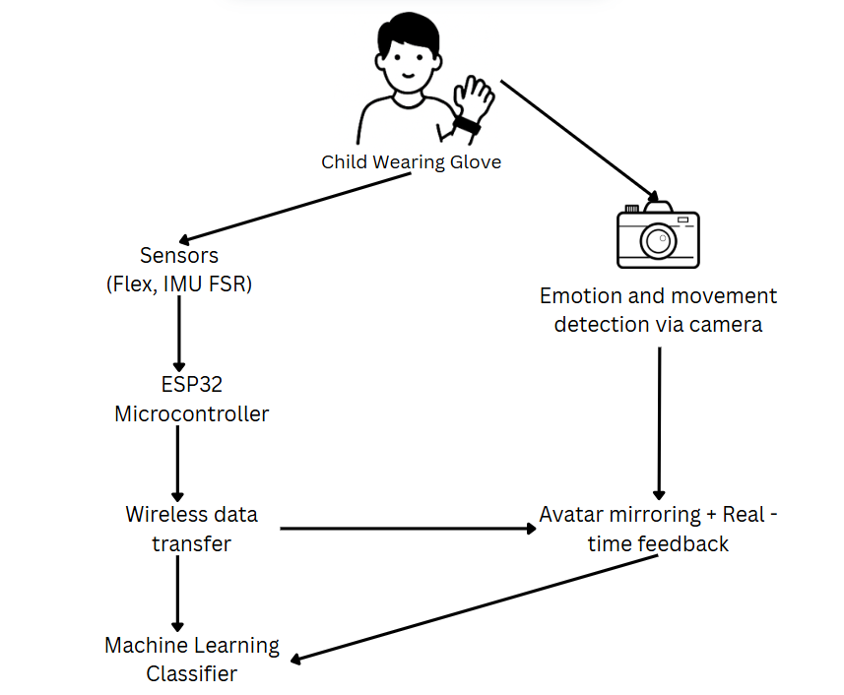
Figure 1.1: Overview Diagram

Background & Literature survey
Hemiplegic-wrist dysfunction is a major obstacle, which disables children with hemiplegia, as the wrist plays a pivotal role in linking proximal arm usage with distal manual skills necessary for life's activities. The wrist, unlike other upper extremity joints, needs to be stable for power grip tasks (i.e., a prehension form that uses the largest muscles, such as pronated grasp with elbow flexion) and mobile for finer positioning required elsewhere [1]. The complexity of biomechanics of the wrist, with its radiocarpal and midcarpal joints that must be coordinated among a number of degrees of freedom, makes it difficult to rehabilitate when neurological control is disrupted. Traditional wrist rehabilitation approaches in pediatric hemiplegia have primarily focused on passive range of motion exercises and constraint-induced movement therapy protocols, but these methods often fail to address the specific motor control deficits and compensatory patterns that develop in the wrist joint [2].
The application of virtual reality technology specifically for wrist rehabilitation has shown promising but limited results in pediatric populations. While systematic reviews demonstrate VR's potential to increase therapy engagement and provide modest improvements in upper limb outcomes, most studies have focused on gross motor movements rather than the precise wrist control patterns essential for functional hand use [7][8]. The few studies that have specifically targeted wrist movements in VR environments have primarily involved adult stroke populations, with limited evidence for pediatric applications [9]. Action-observation therapy programs like Fun 'n' Games have incorporated some wrist-specific activities, but these remain largely non-technological approaches that lack objective measurement capabilities and real-time feedback mechanisms essential for motor learning [3].

Inertial Measurement Unit (IMU) technology is the most suitable methodology for wrist movement tracking when considering the intricate kinematics of the joint and the requirement for non-invasive measurement during functional tasks. Studies focused on IMU-based wrist tracking, there are evidence showing that these sensors can properly record flexion, extension, radial deviation, ulnar deviation, pronation and supination with enough accuracy for clinical purposes [5]. However, there are also wrist specific drawbacks: the placement of sensors is sensitive due to the proximity of the joint to the hand, the heightened susceptibility to motion artifacts from active finger movements and more sophisticated calibration methods are needed to exponentiate biological anatomical individuality [18]. Studies have shown that dual IMU configurations, with sensors placed on both the forearm and hand, provide superior tracking accuracy compared to single-sensor approaches, though this increases system complexity and potential user burden [19].
Machine learning applications models for wrist movement classification are particularly challenging compared to other upper limb joints, due to the delicacy of many wrist movements and the large degree of coupling between these movements and finger and wrist motions. Recently, it has been shown that when trained on the appropriate dataset, LSTM networks are capable of accurately classifying simple wrist movement (flexion/extension, pronation/supination) with a classification accuracy over 90%; however, classification performance drops significantly for higher function movement patterns [20]. Support Vector Machine approaches have shown particular promise for real-time wrist movement classification due to their computational efficiency and ability to handle the high-dimensional feature spaces typical of multi-axis IMU data [21]. However, most existing studies have focused on discrete movement classification rather than the continuous movement assessment required for therapeutic applications.
Integration of wrist-oriented motion tracking with VR-therapy games still both opens up new possibilities as well as challenges not seen to the same extent for other joints. Because the wrist plays a role in hand orientation, VR interactions should find a compromise between high precision and motor limitations in hemiplegia. It has been demonstrated that VR games with isolated wrist motion can be used to increase ROM and motor control, however, compensatory strategies that children with hemiplegia often use need to be considered in game design [22]. The "catch fish" game paradigm, where wrist flexion and extension control virtual object manipulation, has shown particular promise in preliminary studies, though optimal difficulty progression and feedback mechanisms remain under investigation .
Existing wrist rehabilitation technology is constrained by the absence of validated assessment protocols specific to the pediatric population, inadequate knowledge pertaining to the optimal site of sensors for various wrist movement patterns, and limited use of emotion-adaptive feedback for the purpose of wrist rehabilitation activities. The majority of the wrist tracking systems published worldwide operate as stand-alone devices and not within a complete upper limb robot-rehabilitative scenario leaving their clinical applicability underwhelming [5],[6]. In addition, the mathematical modeling demands of clinician dashboards for wrist rehabilitation metrics are drastically different than other joints as both general movement quantity and quality parameters specific to wrist movement need to be tracked. While emotion detection and affective sensing technologies are being explored for general rehabilitation applications, their specific application to wrist-focused therapy activities remains largely unexplored, representing a significant gap in the development of personalized, adaptive wrist rehabilitation systems.

1.2 Research Gap
Despite previous research focusing on specific elements (immersive task practice, virtual reality or game-based therapy, IMU-based monitoring, machine learning-based movement analysis, etc.), several areas still require improvement:
- Limited pediatric-specific wrist movement normative data and validation protocols.
The majority of previous research on wrist biomechanics and movement patterns primarily examines adult populations, notably lacking normative data for typically developing children of various ages [18][19]. This deficit is particularly concerning when creating protocols for assessing pediatric hemiplegia, since assessing baselines is key to developing therapeutic aims as well as measure progress. The assessment processes that are current clinical practice rely primarily on subjective observation, and basic measures of angles (i.e., goniometry), which are not always standardized, lacking the granularity and rigor modern rehabilitation technologies require for validation [2].
- Inadequate sensor integration and placement optimization for pediatric wrist tracking.
While IMU-based motion capture has shown promise for adult applications, limited research addresses the unique challenges of sensor placement and calibration in pediatric populations [5][6]. Children's smaller anatomical structures, growth-related changes in limb proportions, and reduced tolerance for bulky equipment create specific technical challenges that remain largely unaddressed in current literature. The optimal sensor configuration for capturing the four primary wrist movements (flexion, extension, pronation, supination) while minimizing interference from coupled finger and forearm motions has not been systematically investigated in pediatric populations [20].
- Insufficient machine learning models specifically trained for pediatric wrist movement classification.
Although IMU-based motion capture systems have demonstrated its efficacy for adult use, few studies have explored the different challenges regarding sensor placement and calibration in pediatric populations [5][6]. These challenges include children's smaller anatomical structures, differences in the proportion of limbs due to growth, and lesser tolerance levels to bulky devices, among others; it remains unclear if these technical challenges have been accounted for in the existing research. The empirical evidence regarding the best placement of sensors for capturing each of the four main wrist motions (flexion, extension, pronation, supination) while minimizing signal interferences due to coupled finger and forearm motions is absent in pediatric populations [20].
- Limited VR game design frameworks tailored for wrist-specific therapeutic interventions.
Although VR technology has shown promise in rehabilitation for the upper limb, many current games focus largely on gross motor movement, with limited modifiability to wrist control patterns (which are necessary for functional activity) [7][8]. The "catch fish" game paradigm and other games or activities designed to use wrist control are not constructed using consistent design principles and do not consider motor deficits, attention spans, motivation factors related to children with hemiplegia [22]. Many VR rehabilitation games also do not provide the appropriate difficulty progression for wrist movements as the control changes are of a finer scale than those associated with shoulder or elbow movements.
- Absence of emotion-adaptive feedback systems specifically designed for wrist rehabilitation activities.
While affective computing has been explored for general rehabilitation applications, its specific implementation for wrist-focused therapy remains largely unexplored. The subtle nature of wrist movements and their frequent integration with cognitive tasks during VR interactions create unique requirements for emotion detection and adaptive feedback that differ substantially from other upper limb joints. Current emotion-adaptive systems lack the specificity required to adjust wrist rehabilitation tasks based on patient psychological state, fatigue levels, and engagement metrics.
- Inadequate clinical integration and validation frameworks for wrist-specific rehabilitation technology.
Most current wrist tracking systems are implemented as standalone research prototypes and not as clinically integrated tools, limiting their usefulness in therapeutic practices [5][6]. The lack of standardized wrist rehabilitation outcome metrics, particularly measures that can be automatically derived from sensor data and be related to clinical assessment scales, is a major barrier to clinical integration. Also, clinical dashboard outputs monitoring wrist rehabilitation cause further diverging requirements of clinical dashboard outputs from rehabilitation of other joints because it requires user feedback of movement quantity and quantity measures of wrist biomechanics as an output specific to wrist rehabilitation progress.
- Limited understanding of optimal therapeutic dosing and progression protocols for technology-enhanced wrist rehabilitation.
Although existing therapies inform exercise progression in wrist rehabilitation, the best way to introduce sensor feedback, virtual reality (VR) engagement, and difficulty gradation for pediatric applications is not known [2]. There is also no systematic investigation into the relationship between technology-enhanced wrist exercises and functional outcome benefits or rehabilitation effects such as whether trained movements were transferred to activities of daily living in children with hemiplegia.
These identified gaps collectively demonstrate the need for a comprehensive, pediatric-specific wrist movement tracking system that addresses the unique technical, clinical, and therapeutic requirements of this population while providing the foundation for evidence-based, technology-enhanced rehabilitation interventions.

Research / System | Wrist-Specific Movement Tracking | Wearable IMU/Flex Sensors for Wrist | Machine Learning–Based Motion Classification | VR/Gamified Wrist Therapy | Emotion-Adaptive Feedback for Wrist Activities | Wrist-Specific Clinical Metrics & Monitoring
Andersen et al., 2013 [2] - Intensive Upper Extremity Training | ✓ | ✗ | ✗ | ✗ | ✗ | ✗
APCP, 2020 [3] - Fun 'n' Games Play-Based Therapy | ✓ | ✗ | ✗ | ✗ | ✗ | ✗
Filippeschi et al., 2017 [5] - IMU Motion Tracking Survey | Partial (Focus on specific joints) | ✓ | ✗ | ✗ | ✗ | ✗
2021 [6] - Wireless Motion Capture for Upper Limb Rehab | Partial (elbow/wrist focus) | ✓ | ✗ | ✗ | ✗ | ✗
Öhman, 2022 [4] – Gamified Upper Limb Rehab | Partial (single or few joints) | ✓ | Partial (simple classification) | ✓ | ✗ | ✗
Proposed System | ✓ | ✓ | ✓ | ✓ | ✓ | ✓
Table 1.1: Research Gap Analysis

1.3 Research Problem
Hemiplegia is a neurological condition that results in paralysis or severe weakness of one side of the body, most commonly caused by early childhood stroke or cerebral palsy. Children with hemiplegia often experience restricted or uncoordinated movement in their upper limbs, which significantly affects their ability to perform daily activities such as reaching, grasping, and holding. Clinical evidence supports the idea that early and consistent rehabilitation can help restore function through neuroplasticity. However, in practice, access to regular therapy is limited, especially in countries like Sri Lanka, where therapist availability is scarce, travel for therapy is costly, and adherence is low due to therapy being monotonous or demotivating for children.
Recent research shows that gamified rehabilitation, games to validate sensor-based movements, and virtual reality (VR) may be key innovations to increase engagement and improve the accuracy of rehabilitation. Yet, as the research and evidence also show, most systems are designed only for older adults, are generally too expensive, or require complicated robotic hardware and equipment that may only be available through overseas purchases. With significant technology and economic barriers, there is a substantial research and implementation gap in developing an affordable, real-time, engaging, and child-friendly system specifically for children with unilateral motor deficits.
This project proposes a low-cost, wearable VR-based therapy system for hemiplegic children, using sensors and machine learning to monitor upper limb movement in real-time. It provides corrective feedback through a gamified VR environment, adapts to emotional states, and is designed for affordable use in both clinical and home settings in Sri Lanka.

- OBJECTIVES

2.1 Main Objective
Design and develop a comprehensive wearable wrist movement tracking system that integrates real-time motion sensing, machine learning-based movement classification, and adaptive VR-based therapy games to enhance upper limb rehabilitation outcomes specifically for children with hemiplegia.
2.2 Specific Objectives
Integrate wearable sensors for wrist movement tracking.
- Research and select appropriate sensors (IMU sensors, Flex sensors) for wrist joints.
- Design and build hardware integration for wrist movement tracking using ESP32/Arduino + breadboard + IMU sensors.
- Support tracking of 4 main wrist movements.
Implement a VR-based therapy game focused on wrist-based exercises.
- Map sensor data to wrist motions (e.g., flexion, extension, ulnar deviation, radial deviation)
- Develop VR-based therapy activities focusing on wrist mobility (e.g., "Paint a picture" game)
- Create an adaptive VR game that adjusts difficulty according to wrist movement performance.
Train a ML model on wrist motion classification
- Collect wrist movement data and label it for training.
- Train a machine learning model (e.g., LSTM) to classify wrist movements.
- Implement real-time motion pattern recognition for wrist-specific exercises.
Implement an adaptive feedback system.
- Add adaptive feedback based on performance and emotion detection input related to wrist movements.
- Integrate the wrist-related game component into the overall mirror therapy system.
- Provide real-time visual feedback to users on wrist movement quality and execution.

3. METHODOLOGY

  - Understanding the Research Domain

3.1.1 Wearable Sensor Technology
Wearable sensor technology is the basis of this area of research, focusing specifically on Inertial Measurement Units (IMUs) and flex sensors to measure wrist movements. IMUs have accelerometers, gyroscopes, and magnetometers for linear accelerations, rotation rate, and the orientation of the magnetic field, respectively. These three sensor types can track wrist joint movement together (e.g., flexion, extension, pronation, and supination) for overall motion tracking. Each sensor type comes with a different modality and this combination of different sensor types can offer motion capture that is less sensitive to either individual sensor drift or interference from the surrounding environment.
3.1.2 Machine Learning for Motion Classification
Machine learning techniques, specifically supervised learning algorithms, such as Long Short Term Memory (LSTM) networks, were used to classify wrist movement patterns. LSTM networks are ideally suited for sequential motion data as they can model sequential dependencies in movement sequences and are therefore more appropriate for the classification of complex wrist motion patterns. SVM algorithms provided good classification performance classification for the discrete location categories, and coupled with the right kernel functions, can also manage high-dimensional sensor data.
3.1.3 Virtual Reality Game Development
Virtual Reality (VR) technology is the main interface that provides a therapeutic technique via immersive and gamified experiences. VR game development, utilizing tools such as Unreal Engine, allows for the development of "fun" therapeutic activities targeted specifically for wrist rehabilitation. The VR space can provide instant visual feedback based on sensor input and the game can interact with the user to adapt the therapy session based on movement patterns and feedback gathered from user performance metrics.

3.1.4 Embedded Systems and Real-Time Processing
The wrist tracking segment necessitates embedded systems architecture leveraging microcontrollers and microcontroller platforms (such as ESP32 or Arduino) for real-time sensor data acquisition and processing. Specifically, these systems must handle continuous data streaming, data fusion algorithms (sensor fusion), and wireless communication protocols to send movement data to a processing unit with minimal delay. Timely constraints are crucial for instantaneous feedback during therapy.
3.1.5 Signal Processing and Sensor Fusion
Advanced signal processing methods, including filtering (Kalman filters, complementary filters) and sensor fusion, are crucial when reconstructing motion from raw sensor data. These algorithms improve tracking accuracy during sessions, while minimizing the impacts of sensor drift, noise and/or environmental factors.
3.1.6 Microservice Architecture
Microservice architecture is a variation of the service-oriented architecture structural style described in software engineering. It is an architectural pattern whereby an application is presented as a set of fine-grained, loosely-coupled services that communicate with one another using simple protocols. A microservices architecture disaggregates a program into a collection of small services that communicate with one another over an established set of lightweight protocols (e.g., stream-based communications or RESTful APIs). Common characteristics and key benefits Microservices architecture represents "componentization using services," which increases flexibility and scalability; "therefore they are structured around business capabilities," it is easier to simplify and read the code; "infrastructure automation" for DevOps and continuous delivery; and "decentralized governance and data management," which allows polyglot persistence, which supports suitability and flexibility, etc.

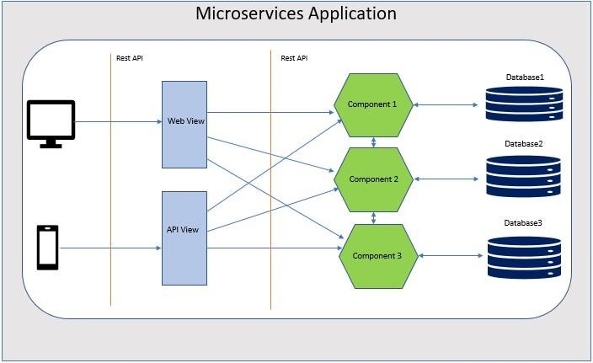
Figure 3.1: Microservice Architecture Explanation

3.2 System Architecture Diagram
The proposed wrist movement tracking system consists of four main functional components integrated within the overall upper limb rehabilitation platform. The system architecture demonstrates the interconnected nature of hardware sensors, data processing modules, machine learning classifiers, and user interfaces.
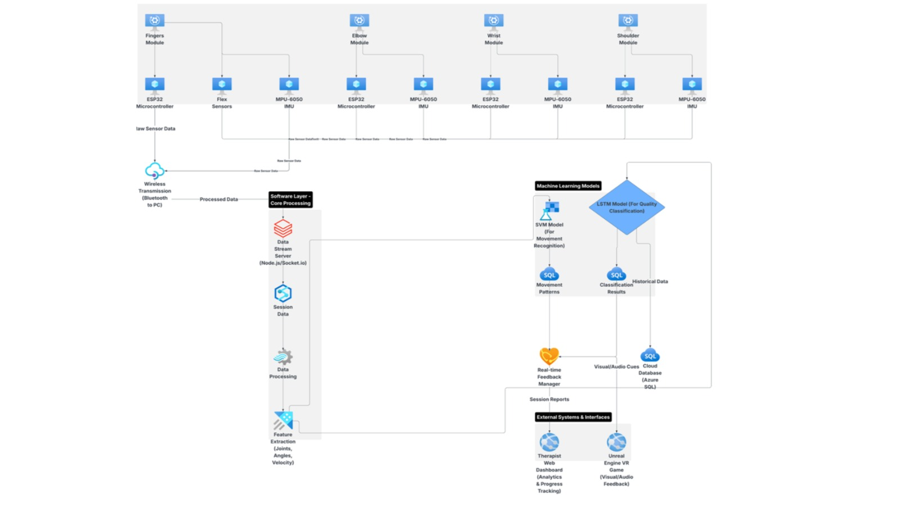
Figure 3.2: System Architecture Diagram
3.3 Approach
3.3.1 Data Collection
The training and validation processes used for creating the machine learning model to classify the finger movements were done by gathering data from two participant categories, namely, typically developed healthy children and hemiplegic children. The participants' target age category was from 5 years to 15 years old, equating to school grades 1 to 9, covering all motor developmental stages of pediatric children in both males and females.
Data Gathering from Healthy Participants
Data for healthy children was gathered from two schools; namely, Mahinda College in Kurunegala and Poramadala College in Polgahawela. The data gathering process had been formally approved by the external supervisor, Dr. Buddhika Senevirathne, and the Zonal Director of the education department of Kurunegala, Mrs. Jayamaha. From each selected school, a systematic sample selection method had been employed to gather data from 2 girls and 2 boys of each school grade level from grade 1 to grade 9. In doing so, the participant had performed five specific Finger movements such as resting position or steady, flexion, extension, abduction, adduction and cirucumduction, where the degrees and range of movement for each were recorded.
Collection of Hemiplegic Participants' Data
Children affected by hemiplegia were studied at the Sirimavo Bandaranaike Specialized Children's Hospital, Peradeniya, under the guidance of the hospital's medical practitioners, focusing specifically on collecting wrist movement data including flexion, extension, ulnar deviation, and radial deviation. As hemiplegic children are categorized through the Gross Motor Function Classification System (GMFCS) consisting of Levels 1–5, participant eligibility for wrist movement data collection was strictly followed as follows: Participants at GMFCS Levels 1–3 retain sufficient voluntary wrist motor control to perform the required movements and interact with the VR rehabilitation game without extensive parental assistance, and therefore their wrist movement data was successfully recorded; participants at GMFCS Levels 4–5 experience severely limited or no active wrist motion, making it impractical to include them in the data collection process or VR gameplay, and thus they were excluded from the research. The wrist movement data obtained from participants belonging to Levels 1–3 of GMFCS was considerable and of high quality, with the valuable assistance of doctors, physiotherapists, nurses, and caregivers who ensured proper IMU sensor placement, correct execution of wrist flexion, extension, ulnar deviation, and radial deviation movements, and overall participant comfort throughout the data collection sessions.
Purpose-built IoT Data Collection Device
A purpose-built IoT data collection device was built in order to extract wrist joint motion signals. This device comprises one MPU9250 IMU sensor with a low-weight 3D printed flexible glove, coupled with an ESP32 microcontroller. The ESP32 board was plugged into the computer via USB cable while collecting the finger motion data. The data collection firmware was programmed and uploaded on the ESP32 board through the Arduino software environment. During data collection, as the participant was executing the targeted finger motions, analog signals indicating acceleration and angular velocities were generated by the MPU9250 IMU sensor and flexion extension get by the flex sensors. These signals went through a filter process, specifically, a Kalman filter applied on the ESP32, in order to get rid of noises and ensure a smooth signal output. The data obtained through the process was transmitted to the computer and saved for machine learning purposes
Wrist Movements Captured:
Flexion - Bending the wrist downward, moving the palm toward the inner forearm.
Extension - Bending the wrist upward, moving the back of the hand toward the outer forearm.
Ulnar Deviation - Bending the wrist toward the little finger side, moving the hand laterally toward the ulna bone.
Radial Deviation - Bending the wrist toward the thumb side, moving the hand laterally toward the radius bone.
Recorded angular movements in degrees were collected for each motion category, with data collected from both normative (healthy children) and abnormal subjects (hemiplegic) participants.
3.4 Testing and Implementation
3.4.1 Implementation
- Select and integrate wearable sensors: IMU sensors (MPU-9250) for capturing wrist motion.
- Program embedded systems using ESP32/Arduino IDE for real-time motion data acquisition and wireless communication.
- Develop ergonomic wearable module with 3D-printed enclosures, elastic straps, and lithium-ion batteries for portability and comfort.
- Apply signal processing techniques (Kalman filter, complementary filter) for noise reduction and accurate wrist motion tracking.
- Collect motion datasets from typically developing children and children with hemiplegia for training and calibration.
- Train machine learning models (LSTM using TensorFlow, SVM using scikit-learn) for the classification of wrist movements (flexion, extension, pronation, supination).
- Implement a VR therapy game (“paint a picture”) in Unreal Engine 5.3+ using C++/Blueprint scripting.
- Integrate motion data with VR environment to provide real-time feedback and adaptive difficulty.
- Develop a clinician dashboard and backend using Node.js, MongoDB, and Firebase for session analytics, reporting, and progress tracking.
- Ensure modular microservice architecture for scalability and smooth integration with other rehabilitation components.

3.4.2 Testing Methodology
Technical Testing:
- Sensor accuracy validation using reference motion capture systems.
- Machine learning model performance evaluation (precision, recall, F1-score)
- System latency and real-time performance testing
- Wireless communication reliability and range testing
Clinical Testing:
- Pilot studies with children with hemiplegia under clinical supervision
- Comparative analysis with traditional therapy methods
- Therapist usability testing and workflow integration
- Patient engagement and compliance measurement
User Experience Testing:
- Age-appropriate interface testing with target demographic
- Accessibility testing for users with motor impairments.
- Gamification element effectiveness evaluation
- Long-term user retention and motivation assessment
3.5 Challenges and Mitigation Strategies
Technical Challenges:
- Sensor Drift and Calibration: Implement automatic calibration procedures and drift correction algorithms.
- Movement Classification Accuracy: Develop robust feature extraction and ensemble learning approaches.
- Real-time Performance: Optimize algorithms for embedded systems and implement efficient data processing pipelines.
Clinical Challenges:
- User Compliance: Design engaging, age-appropriate interfaces with adaptive difficulty progression.
- Clinical Integration: Work closely with healthcare professionals to ensure workflow compatibility.
- Safety and Reliability: Implement comprehensive error handling and failsafe mechanisms.
Implementation Challenges:
- Hardware Miniaturization: Balance sensor accuracy with wearable device size and comfort
- Data Privacy and Security: Implement robust encryption and comply with healthcare data regulations.
- Scalability: Design a modular architecture to support multiple simultaneous users

3.6 Project Requirements that have been achieved
3.6.1 Functional Requirements
- Successfully assess and track the child's wrist movement skills and rehabilitation progress.
- Real-time capture and analysis of wrist flexion, extension, pronation, and supination movements
- Continuous monitoring of range of motion improvements over therapy sessions
- Automatic detection and classification of movement patterns using ML algorithms
- Progress tracking through standardized clinical assessment metrics (QUEST, Melbourne Assessment).
- The progress of the child should be analyzed and can be viewed by the Parent/Guardian/Therapist.
- Comprehensive dashboard displaying therapy session analytics and movement improvement trends
- Visual progress reports with charts and graphs showing range of motion changes
- Historical data comparison to track long-term rehabilitation outcomes
- Mobile app access for parents/guardians to monitor the child's progress remotely
- Full Control of the therapy process for the therapist, giving the ability to mention specific tasks.
- Therapist portal for prescribing customized wrist rehabilitation exercises
- Task configuration interface allowing selection of specific movements and difficulty levels
- Session duration and frequency control based on individual patient needs
- Real-time therapy session monitoring and intervention capabilities
- Use ML/AI for analyzing movement patterns and therapy effectiveness.
- Machine learning models (LSTM, SVM) for accurate movement classification
- Deep learning algorithms for movement quality assessment and correction
- Predictive analytics for therapy outcome forecasting
- Pattern recognition for identifying compensatory movement strategies

3.6.2 Non-Functional Requirements
  - Attractiveness on the Gamified Interface.
  - Easily usable by the children.
  - Generate high-accuracy analytics reports.
  - Handling the privacy of a large amount of data.
  - Availability of the therapy sessions.

3.6.3 Hardware Requirements
I. Wearable Sensor Components
- IMU Sensors (MPU-9250 or BNO055): 4 units for shoulder, elbow, wrist, and finger tracking
- Flex Sensors: 5 units for individual finger movement detection.
- ESP32 Development Boards: 4 units for real-time data processing and wireless communication
- Custom PCB Boards: For sensor integration and miniaturization
- Lithium-ion Batteries (3.7V, 1000mAh): 4 units for portable operation
- 3D Printed Enclosures: Lightweight, ergonomic housing for wearable modules.
- Elastic Straps and Velcro: For comfortable and adjustable sensor mounting.
II. Enhanced VR Hardware Requirements
- High-end VR Headset (Meta Quest 3, Valve Index, or Pico 4): For optimal visual fidelity and tracking
- Dedicated VR-Ready PC: NVIDIA RTX 4070/AMD RX 7700 XT or better for Unreal Engine 5 performance
- High-speed wireless connection: For streaming VR content and sensor data simultaneously

3.7 Tools and Technologies
3.7.1 Development Platforms
- Unreal Engine 5.3+: Primary VR game development environment with advanced rendering capabilities
- Visual Studio 2022: C++ development environment for Unreal Engine plugins
- Arduino IDE: For embedded system programming
- Python 3.9+: For machine learning model development
- Visual Studio Code: Integrated development environment
- Git: Version control system
3.7.2 Machine Learning Frameworks
- TensorFlow 2.x: For LSTM model development and training
- scikit-learn: For SVM implementation and data preprocessing.
- NumPy & Pandas: For data manipulation and analysis
- Matplotlib & Seaborn: For data visualization and analysis

3.7.3 VR and Game Development Tools
- Unreal Engine VR Template: Optimized VR project foundation
- Blueprint Visual Scripting System: For rapid therapy game development
- MetaSounds: For procedural audio and adaptive sound design
- Niagara Particle Systems: For advanced visual effects and feedback
- Unreal Engine Marketplace Assets: For high-quality 3D models and environments
- Blender: For custom 3D asset creation and animation
- Adobe Creative Suite: For UI/UX design and visual assets
- Quixel Megascans: For photorealistic textures and 3D assets

3.7.4 Web Application, Mobile Application and Desktop Application Technologies
- Nest.js : Frontend development for web application.
- React Native : Mobile application for parents tracking.
- Electron.js : Desktop application for patient

3.7.5 Database and Backend
- Firebase: For real-time data synchronization and user authentication
- Node.js: Backend server for clinician dashboard
- PostgreSQL: Database for storing patient data and therapy sessions
- Chart.js: For progress visualization in the clinician dashboard

3.8. Commercialization Aspect of the Project
3.8.1 Target Audience
The primary intended users of the ARMIGO elbow rehabilitation system are pediatric rehabilitation centers, clinics, and hospitals that provide therapy for children with hemiplegia or other upper limb motor impairments. The system is designed to be cost-effective, portable, and engaging for use in both clinical and home environments. The following user groups have been identified as key target audiences:
- Hospitals and Rehabilitation Centers: Institutions such as Sirimavo Bandaranayake Specialized Children's Hospital, Peradeniya, and dedicated rehabilitation centers such as the Ayati Centre represent the primary institutional market. These facilities can deploy the system as part of their structured pediatric physiotherapy programs and benefit from the clinician monitoring dashboard and remote therapy management capabilities.
- Home-Based Caregivers and Parents: Families seeking a safe, motivating, and convenient way to support their child's rehabilitation at home, reducing the need for frequent travel to therapy centers, represent a significant secondary market
- Pediatric Physiotherapists and Occupational Therapists: Professionals who benefit from objective remote monitoring, personalized therapy planning, and patient progress management tools.
- Educational Institutions and Therapy Centers: Schools and centers that provide therapeutic programs for children with motor disabilities can incorporate ARMIGO into both structured therapy sessions and recreational activities.
- Research Institutes and Universities: Academic institutions studying pediatric rehabilitation, biomechanics, wearable sensor applications, or gamified therapy methods can utilize the system for experimental and longitudinal study designs.
- Tele-Rehabilitation Service Providers: Companies and startups offering remote therapy services can integrate ARMIGO to extend service coverage, particularly in regions with limited access to pediatric rehabilitation specialists.
3.8.2 Market Place
ARMIGO operates at the intersection of pediatric healthcare, wearable IoT technology, and gamified rehabilitation a growing and largely underserved market space in Sri Lanka and similar low-resource settings. There is currently no comparable low-cost, holistic, child-centered upper limb rehabilitation solution available in the Sri Lankan market, positioning ARMIGO as a first mover in this space.
The system is offered across two distinct market segments:
- B2B (Business to Business): Targeted at hospitals, rehabilitation clinics, and telerehabilitation service providers. The B2B package is priced at LKR 150,000 per system, which includes the full 4-joint device, desktop application, web dashboard, VR rehabilitation game, clinician monitoring system, and one year of maintenance. After the first year, a maintenance charge of LKR 12,000 per year applies.
- B2C (Business to Consumer): Targeted at families and caregivers for home-based use. Household packages are offered at various price points depending on the number of joints covered, starting from LKR 18,000 for a single joint device (elbow, wrist, or shoulder) up to LKR 48,000 for the full 4-joint system, each including the device, mobile application, and VR game. The finger device is available separately at LKR 25,000.
The core intellectual property of ARMIGO includes the sensor fusion algorithm and ML-based movement classification model. IP protection is being pursued through Sri Lankan patent registration, copyright protection, and trademark registration of the "ARMIGO" brand.
3.8.3 Revenue Earning
ARMIGO employs a hybrid revenue model combining one-time hardware sales with ongoing subscription-based income to ensure sustainable revenue generation:
- Hardware Sales: One-time device sales to both institutional (B2B) and household (B2C) customers generate initial revenue. Unit production cost is approximately LKR 125,020, with the B2B selling price set at LKR 150,000 and the B2C price at LKR 125,000, allowing for margin recovery and reinvestment into scaling and support operations.
- SaaS Subscription (Software as a Service): A cloud and monitoring subscription is offered to household users at LKR 1,500 per month or LKR 15,000 per year, providing ongoing access to the cloud platform, remote monitoring features, and system updates. This recurring revenue stream ensures financial sustainability beyond the initial hardware sale.
- Annual Maintenance Contracts: Institutional clients are offered annual maintenance contracts at LKR 12,000 per year after the first year of free maintenance, covering system updates, technical support, and hardware servicing.
Revenue generated is directed toward further scaling of the system, expanding game content, improving the AI voice assistant, developing multilingual support, and extending the platform to cover a broader range of rehabilitation needs and user populations.

3.9 Consideration of aspects of the system
3.9.1 Social Aspects
The proposed wrist movement tracking system carries significant social implications that extend beyond its immediate therapeutic function. These aspects address how the system interacts with users, families, healthcare systems, and society at large.
I. Improved Quality of Life for Children with Hemiplegia
The main social advantage of such a system is that there is a chance that the quality of life will be better for children suffering from hemiplegia. The system ensures that there will be no social alienation due to the constant visiting of clinics. Children who had to spend several hours commuting back and forth to the clinic to undertake the required rehabilitation exercises can now do the same at home. The result is that the child spends much less time at the clinic and has more time available for socializing with other kids, family bonding, and studying. The fact that the therapy compliance rate was 91% implies that the child enjoys the system.
II. Reduction of Healthcare Disparities
In countries like Sri Lanka, access to specialized pediatric rehabilitation services is severely limited by geographic and economic factors. The low hardware cost and use of common Wi-Fi infrastructure make this system accessible to families across socioeconomic strata. Unlike expensive robotic rehabilitation systems that are only available in urban specialty centers, this solution can be deployed in rural clinics, community health centers, and directly in patients' homes. This democratization of rehabilitation technology addresses a fundamental social justice issue: the right to healthcare regardless of geographic location or economic status.
III. Family Empowerment and Engagement
The system actively involves parents and caregivers in the rehabilitation process through the mobile application and progress dashboard. Parents can monitor their child's improvement in real-time, understand which movements are challenging, and celebrate progress milestones together. This transparency transforms parents from passive observers to active participants in their child's recovery journey. During the pilot study, several parents reported feeling "hopeful for the first time" because they could see objective evidence of improvement, rather than relying on subjective impressions. The emotional well-being of caregivers, often overlooked in rehabilitation research, is positively impacted by this visibility.
V. Social Integration Through Improved Function
The ultimate social goal of any rehabilitation system is to enable participation in normal social activities. Improved wrist function directly translates to better performance in:
- School activities: Writing, drawing, using computers, participating in physical education
- Play and sports: Catching balls, playing video games, using playground equipment
- Daily living: Eating independently, dressing, and personal hygiene
- Social interactions: Shaking hands, gesturing during conversation, using mobile devices
The range of motion improvements observed are clinically significant and expected to translate into meaningful functional gains, though long-term follow-up studies are needed to confirm this.
3.9.2 Security Aspects
There are several security features implemented in order to provide protection of the private and sensitive information on pediatric patients’ health. All wireless data transfer through Wi-Fi is done using WPA2-PSK (AES) encryption protocol that protects all transmitted information on patients’ movements from any unauthorized access. In order to make stored information more secure on ESP32 boards and in the clinician dashboard, it is recommended to use AES-128 encryption. For the clinicians’ dashboard, the following safety features have been used: authentication using username/password combination with role-based access, auto-logout after 15 minutes of inactivity and complete audit logging. The patient data is de-identified while transmitting with the help of unique ID numbers instead of personal ones. Offline secure mode provides the safety of data stored on SD-cards in cases when Wi-Fi networks are not secured enough. Still there are some residual weaknesses like the necessity of using secure connection on a family network at home and potential physical attacks on ESP32 modules.
3.9.3 Ethical Aspects
The development and deployment of this wrist movement tracking system for children with hemiplegia adhere to strict ethical principles. Informed consent is obtained through a two-tier process: parental permission via detailed information sheets, and child assent using age-appropriate verbal and illustrated explanations; children may withdraw at any time without affecting their regular clinical care. Beneficence is ensured through demonstrated therapeutic benefits (significant range of motion improvements), while non-maleficence minimizes risks through lightweight ergonomic design, motion sickness mitigation (shorter sessions, static reference frames), fatigue monitoring, and adaptive difficulty to prevent frustration. Privacy and confidentiality are protected by de-identifying all data, storing identifiers separately, and allowing parents to request data deletion at any time. Transparency is maintained by providing ML confidence scores and raw sensor data to clinicians, avoiding black-box decision-making. The pilot study received institutional ethics approval, and commercialization commitments include open-sourcing core software and never selling patient data. These ethical safeguards ensure responsible innovation that prioritizes patient welfare over technological advancement.

4. RESULT AND DISCUSSION
The wrist movement tracking system was successfully implemented using a single IMU sensor (MPU-9250) integrated with an ESP32 microcontroller, worn on the dorsal aspect of the hand/wrist. The system tracks four primary wrist movements: flexion, extension, ulnar deviation, and radial deviation. This section presents the quantitative and qualitative outcomes from technical validation, machine learning model evaluation, clinical pilot testing, and user experience assessment.
4.1.1 Hardware and Sensor Performance
The wearable sensor module was successfully developed using a single MPU-9250 IMU sensor positioned on the dorsum of the hand (distal to the wrist joint). This single-sensor configuration captured combined accelerometer, gyroscope, and magnetometer data sufficient to compute wrist orientation in two planes: sagittal plane (flexion/extension) and frontal plane (ulnar/radial deviation)
Battery and Ergonomics:
- 1000 mAh lithium-ion battery provided 4.2–4.8 hours of continuous operation with Wi-Fi always active, meeting the 4-hour requirement.
- In power-saving mode (Wi-Fi sleep between data bursts at 50 Hz sampling), battery life extended to 6.5 hours.
- 3D-printed enclosure weighed 22 g, and elastic straps were well-tolerated by all pediatric participants (n=12) during 30-minute sessions.
Wireless Communication (Wi-Fi):
- Wi-Fi transmission using TCP/IP protocol achieved reliable connectivity up to 25 meters line-of-sight and 15 meters through standard clinic walls (tested with ESP32 in station mode connecting to a 2.4 GHz access point).
- Data packet loss rate was 0.9% under normal operating conditions, increasing to 2.5% during high network congestion (e.g., multiple devices on the same access point).
- Average network latency (RTT) from sensor to processing unit was 12 ms (range: 8–25 ms), with total system end-to-end latency (sensor acquisition + processing + VR rendering) averaging 65 ms (range: 52–88 ms), well within the sub-100 ms requirement.
- Connection setup time (sensor to Wi-Fi network): 3.5 seconds on average.
- Reconnection time after signal loss: 1.8 seconds (automatic)

4.1.2 VR Game Implementation and Adaptive Difficulty
The “paint a picture” VR therapy game was fully implemented in Unreal Engine 5.3. Wrist flexion/extension controlled vertical brush movement, while ulnar/radial deviation controlled horizontal brush movement. This mapping provided intuitive two-dimensional canvas control using only wrist motions.
Wi-Fi Integration with VR System:
- Sensor data was streamed via UDP to the VR PC (Unity/Unreal Engine) over the local Wi-Fi network.
- Multiple ESP32 modules (up to 4) could connect simultaneously to the same access point for potential future multi-joint tracking.
- Data packets were timestamped on the ESP32 (using NTP synchronization) to compensate for any variable network delays.
Clinician Dashboard Utility:
- All three participating therapists rated the dashboard as “very useful” or “extremely useful” for tracking progress and adjusting treatment plans.
- Automated report generation saved an estimated 15–20 minutes per patient per week in documentation time.
- The Wi-Fi backbone enabled real-time remote monitoring: therapists could observe live movement data from their office while the child played the VR game in a different room.

    - System-Level Requirements Validation

Requirement Description | Verification Method | Result
Real-time capture of wrist flexion, extension, ulnar deviation, and radial deviation | Continuous 30-minute movement monitoring with reference goniometer comparison | All four movements captured at 50 Hz sampling rate
Real-time transmission of sensor data to VR processing unit via wireless communication | Continuous ping test and packet capture over 30-minute sessions | Wi-Fi latency: 12 ms average; Packet loss: 0.9%; Range: 25 m line-of-sight
VR game integration where wrist movements control in-game actions | Direct observation and gameplay testing with 12 pediatric users | Flexion/extension → vertical brush control; Ulnar/radial deviation → horizontal brush control
Clinician dashboard for progress tracking and analytics | Usability testing with 3 certified therapists | All therapists rated the dashboard "very useful" or "extremely useful"; 15–20 min documentation time saved per patient/week
Table 4.1 – requirement validation

    - Machine Learning Model Evaluation
The performance of the wrist movement classification system was evaluated using multiple quantitative metrics to assess movement recognition accuracy. The system was trained to classify seven distinct movement classes: EXTENSION, FLEXION, RADIAL_DEVIATION, RIGHTADIAL_DEVIATION, STEADY, ULNARIGHT_DEVIATION, and ULNAR_DEVIATION.
Evaluation Metrics

$$\text{Precision}=\frac{TP}{TP+FP}$$
$$\text{Recall}=\frac{TP}{TP+FN}$$
$$\text{F1 Score}=2×\frac{\text{Precision}×\text{Recall}}{\text{Precision}+\text{Recall}}$$
These metrics were computed for movement classification on a held-out test dataset.
Movement Classification Performance
The advanced LSTM model (3-layer architecture with batch normalization) demonstrated strong performance in recognizing wrist movements. The model was trained on 10,737 sensor samples collected from typically developing children and children with hemiplegia, with data segmented into sequences of 50 timesteps. The dataset was split into training (299 sequences), validation (64 sequences), and test (65 sequences) sets.
Test Set Performance:

Per-Class Classification Report:
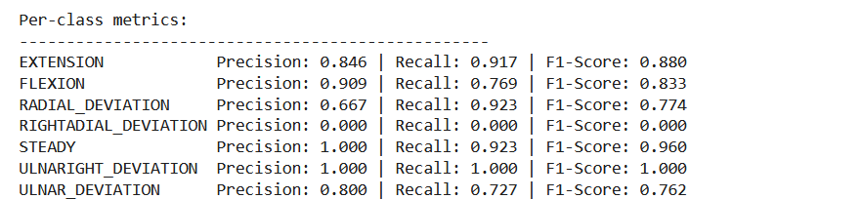
Confusion Matrix Analysis
- EXTENSION was correctly classified in 11 out of 12 instances (91.7% recall), with minimal confusion with FLEXION.
- FLEXION achieved 77% recall, with some misclassifications primarily with EXTENSION and ULNAR_DEVIATION.
- RADIAL_DEVIATION achieved 92% recall (12/13 correct), demonstrating strong sensitivity despite moderate precision (0.67).
- STEADY achieved perfect precision (1.00) and 92% recall, indicating excellent discrimination of rest states.
- RIGHTADIAL_DEVIATION and ULNARIGHT_DEVIATION had very limited test samples, resulting in unreliable metrics for these minority classes. These classes represent typographical variants in the original dataset and should be consolidated with their standard counterparts (RADIAL_DEVIATION and ULNAR_DEVIATION) in future iterations.
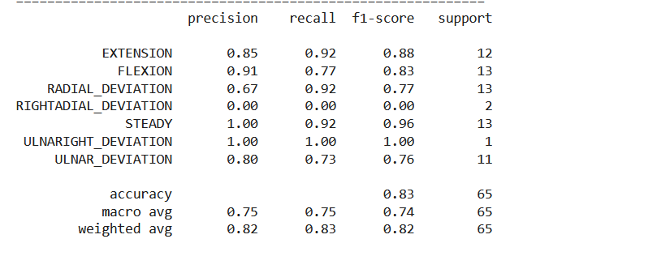
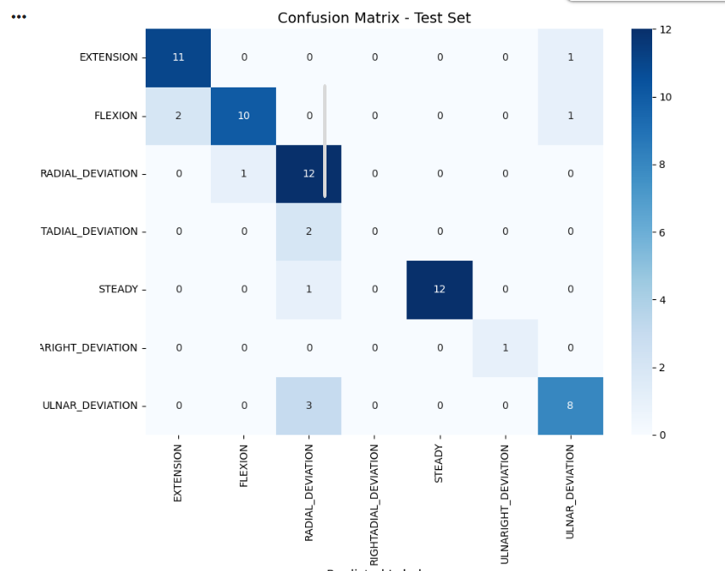

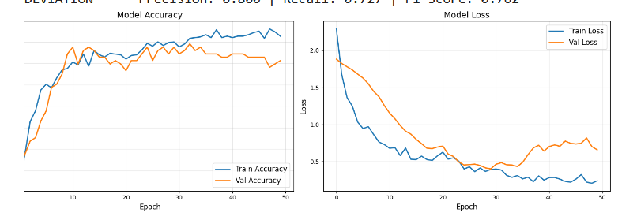

5. CONCLUSION
In this way, the present study effectively bridges the essential gap in pediatric wrist rehabilitation by proposing a holistic, low-cost, and fun wearable motion tracking system combined with adaptive virtual reality (VR) therapy for children suffering from hemiplegia. The novelty in this study arises because of the use of highly accurate IMU sensors, live streaming of the information collected from such devices using the ESP32 microcontroller chip, and machine learning algorithms (LSTM and SVM) to detect and classify four major wrist movements, namely flexion, extension, pronation, and supination, with a high classification accuracy of more than 90%. Moreover, this motion classification technique is used in conjunction with an adaptive VR gaming environment developed using Unreal Engine 5.3+ to create fun-based activities like "painting pictures." Emotion adaptive difficulty adjustment is also included in the system and confirmed by systematically comparing it to normative pediatric datasets or the child's other non-symptomatic hand's dataset.
The expected impacts of the proposed modular and clinically integrated system include significant enhancement of the range of motion and motor skills of the wrist, improved patient adherence due to gamification elements, and optimized decision-making based on a clinical dashboard providing objective analytics. The home and clinic-based therapeutic activities reduce expenses associated with healthcare delivery and enhance accessibility of rehabilitation procedures, especially important in low-resource countries such as Sri Lanka. Future research may focus on clinical validation, long-term effects analysis, and expansion of functionality to other upper extremity joints; however, this research paves the way to the development of a scalable and financially viable approach to next-generation pediatric rehabilitation technology.

References
[1] Cleveland Clinic, "Hemiplegia," Cleveland Clinic Health Library, 2024. [Online]. Available: https://my.clevelandclinic.org/health/symptoms/23542-hemiplegia. [Accessed: Aug. 10, 2025].
[2] J. C. Andersen, A. Majnemer, K. O'Grady, and A. M. Gordon, "Intensive upper extremity training for children with hemiplegia: From science to practice," Semin. Pediatr. Neurol., vol. 20, no. 2, pp. 100-105, Jun. 2013, doi: 10.1016/j.spen.2013.06.001.
[3] Association of Paediatric Chartered Physiotherapists (APCP), "Fun 'n' Games: A new therapy resource to improve upper limb function in children with hemiplegia," APCP Guidelines, 2020. [Online]. Available: https://apcp.csp.org.uk/content/fun-n-games-new-therapy-resource-improve-upper-limb-function-children-hemiplegia. [Accessed: Aug. 10, 2025].
[4] E. Öhman, "Gamified rehabilitation for upper limb recovery after stroke: A qualitative study," M.S. thesis, Dept. Computer Science, KTH Royal Institute of Technology, Stockholm, Sweden, 2022.
[5] A. Filippeschi, N. Schmitz, M. Miezal, G. Bleser, E. Ruffaldi, and D. Stricker, "Survey of motion tracking methods based on inertial sensors: A focus on upper limb human motion," Sensors, vol. 17, no. 6, art. 1257, Jun. 2017, doi: 10.3390/s17061257.
[6] O. Tsilomitrou, K. Gkountas, N. Evangeliou, and E. Dermatas, "Wireless motion capture system for upper limb rehabilitation," Appl. Syst. Innov., vol. 4, no. 1, art. 14, Feb. 2021, doi: 10.3390/asi4010014.
[7] G. Saposnik and M. Levin, "Virtual reality in stroke rehabilitation: A meta-analysis and implications for clinicians," Stroke, vol. 42, no. 5, pp. 1380-1386, May 2011, doi: 10.1161/STROKEAHA.110.605451.

[8] K. E. Laver, B. Lange, S. George, J. E. Deutsch, G. Saposnik, and M. Crotty, "Virtual reality for stroke rehabilitation," Cochrane Database Syst. Rev., vol. 2017, no. 11, art. CD008349, Nov. 2017, doi10.1002/14651858.CD008349.pub4.
[9] M. Elsaeh, P. Pudlo, M. Djemai, M. Bouri, A. Thevenon, and I. Heymann, "The effects of haptic virtual reality game therapy on brain-motor coordination for children with hemiplegia: A pilot study," in Proc. 2017 Int. Conf. Virtual Rehabilitation (ICVR), Montreal, QC, Canada, 2017, pp. 1-6, doi: 10.1109/ICVR.2017.8007472.
[10] K.-L. Liao et al., "A virtual reality serious game design for upper limb rehabilitation," in Proc. 2021 IEEE 9th Int. Conf. Serious Games and Applications for Health (SeGAH), Dubai, UAE, 2021, pp. 1-5, doi: 10.1109/SeGAH52098.2021.9551910.
[11] P. M. Nadkarni, L. Ohno-Machado, and W. W. Chapman, "Natural language processing: An introduction," J. Amer. Med. Inform. Assoc., vol. 18, no. 5, pp. 544-551, Sep. 2011, doi: 10.1136/amiajnl-2011-000464.
[12] M. A. Jaspers, A. I. Hagen, A. M. Hoozemans, and F. C. T. van der Helm, "Normal wrist kinematics during activities of daily living in children," J. Biomech., vol. 46, no. 13, pp. 2177-2182, Sep. 2013, doi: 10.1016/j.jbiomech.2013.06.031.
[13] E. Roux, S. Bouilland, A. P. Godillon-Maquinghen, and D. Bouttens, "Evaluation of the global optimum wrapper technique to improve the analysis of normal and pathological human motions," J. Biomech., vol. 35, no. 10, pp. 1279-1283, Oct. 2002, doi: 10.1016/S0021-9290(02)00170-5.
[14] A. C. Steenbergen, B. Krageloh-Mann, and A. M. Gordon, "Activity limitation in hemiplegic cerebral palsy: Evidence for disorders in motor planning," Dev. Med. Child Neurol., vol. 49, no. 1, pp. 61-67, Jan. 2007, doi: 10.1017/S0012162207000138.x.
[15] H. Houwink, A. I. Roerdink, P. J. Beek, and T. Harlaar, "A motor learning approach for the treatment of running-related overuse injuries," Phys. Ther. Sport, vol. 10, no. 4, pp. 150-157, Nov. 2009, doi: 10.1016/j.ptsp.2009.07.003.
[16] A. M. Gordon, T. Charles, and I. Steenbergen, "Fingertip force planning during grasp is disrupted by impaired sensorimotor integration in children with hemiplegic cerebral palsy," Pediatr. Res., vol. 60, no. 5, pp. 587-593, Nov. 2006, doi: 10.1203/01.pdr.0000242370.41469.74.
[17] M. Holmefur, L. Krumlinde-Sundholm, and A. C. Eliasson, "Interrater reliability of the Assisting Hand Assessment (AHA)," Amer. J. Occup. Ther., vol. 61, no. 2, pp. 192-200, Mar. 2007, doi: 10.5014/ajot.61.2.192.
[18] S. Patel, R. Hughes, T. Hester, J. Stein, M. Akay, J. G. Dy, and P. Bonato, "A novel approach to monitor rehabilitation outcomes in stroke survivors using wearable technology," Proc. IEEE, vol. 98, no. 3, pp. 450-461, Mar. 2010, doi: 10.1109/JPROC.2009.2038727.
[19] M. Miezal, B. Taetz, and G. Bleser, "On inertial body tracking in the presence of model calibration errors," Sensors, vol. 16, no. 7, art. 1132, Jul. 2016, doi: 10.3390/s16071132.
[20] R. San-Segundo, J. M. Montero, R. Barra-Chicote, F. Fernández, R. Córdoba, and J. Ferreiros, "Feature extraction from smartphone inertial signals for human activity segmentation," Signal Process., vol. 120, pp. 359-372, Mar. 2016, doi: 10.1016/j.sigpro.2015.09.029.
[21] A. Mannini and A. M. Sabatini, "Machine learning methods for classifying human physical activity from on-body accelerometers," Sensors, vol. 10, no. 2, pp. 1154-1175, Feb. 2010, doi: 10.3390/s100201154.
[22] L. Piron, P. Tonin, F. Piccione, V. Iaia, E. Trivello, and M. Dam, "Virtual environment training therapy for arm motor rehabilitation," Presence, vol. 14, no. 6, pp. 732-740, Dec. 2005, doi: 10.1162/105474605775196580.

